**Data Cleaning – Syed Wasti**

My cleaning philosophy: Due to each country having vastly different values I did the cleaning row by row, country by country.

If there is only one value present, I would copy that value for every other cell in the row.

If only one cell is missing, I will use median if the other values have outliers, mean if the other values are similar and finally just copy the values right next to the cell if the values are ascending or descending.

If any rows have all 0’s or nan’s then i will remove the row.

Median for rows with outliers and mean for values that are similar.

**Done = 2 in environment and 3 in medical**

Plastic waste:

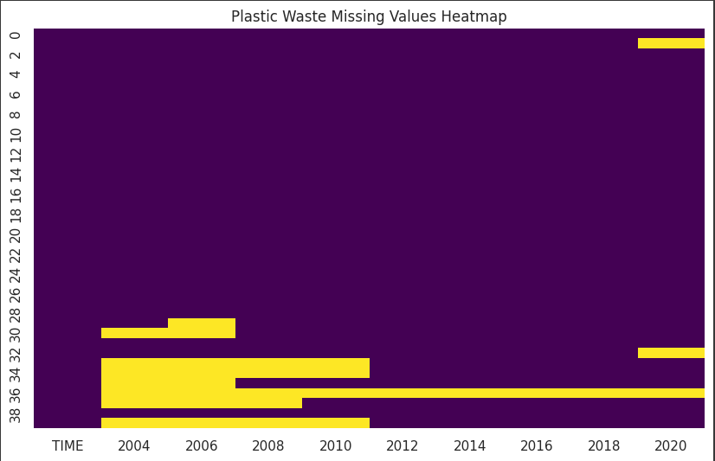

Before:

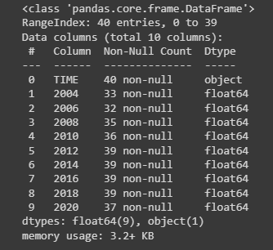

After:

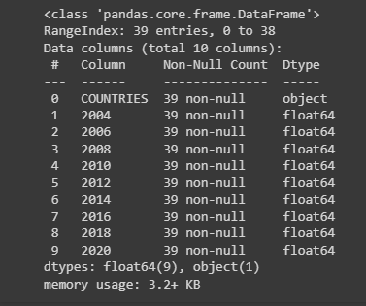

Medical waste:

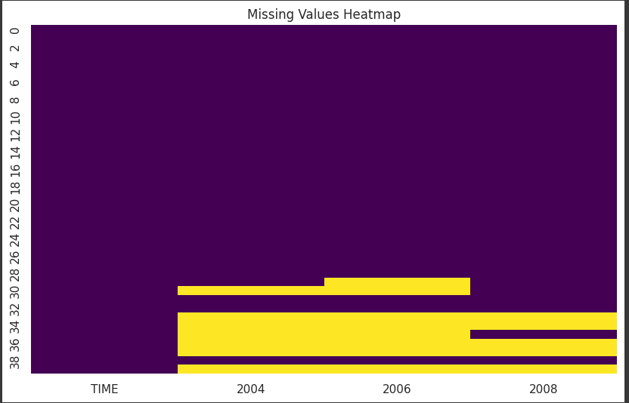

Before:

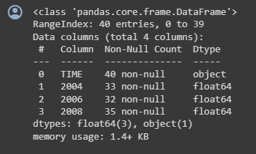

After:

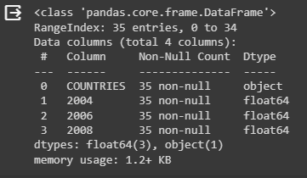

Chemical waste:

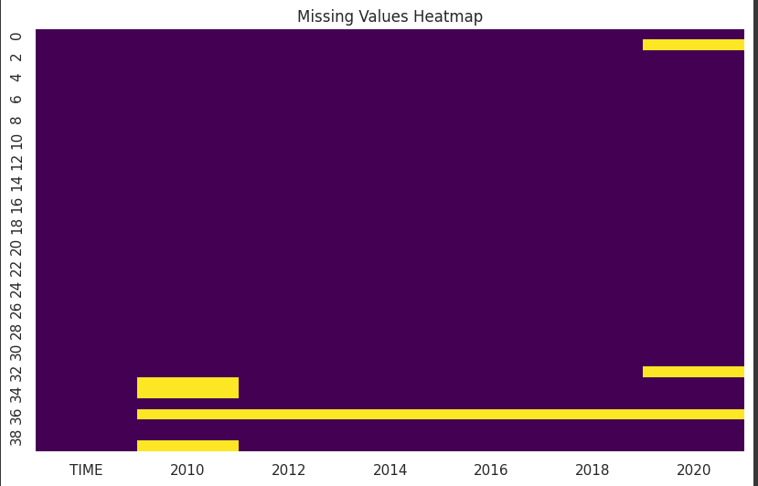

Before:

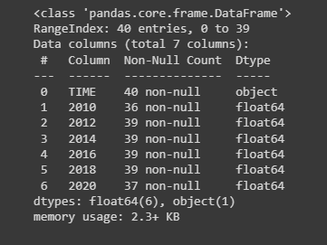

After:

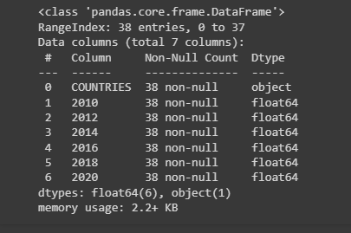

**Soil contamination:**

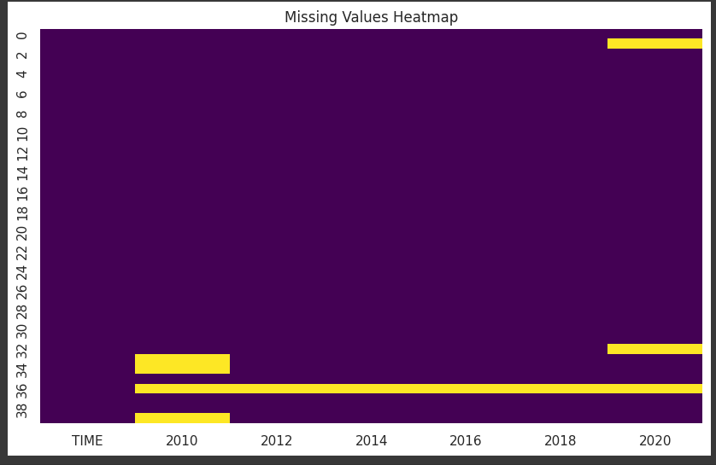

Before:

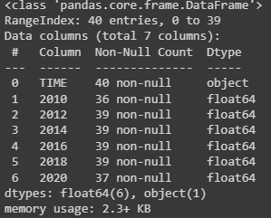

After:

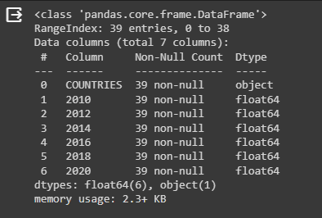

**Water pollution:**

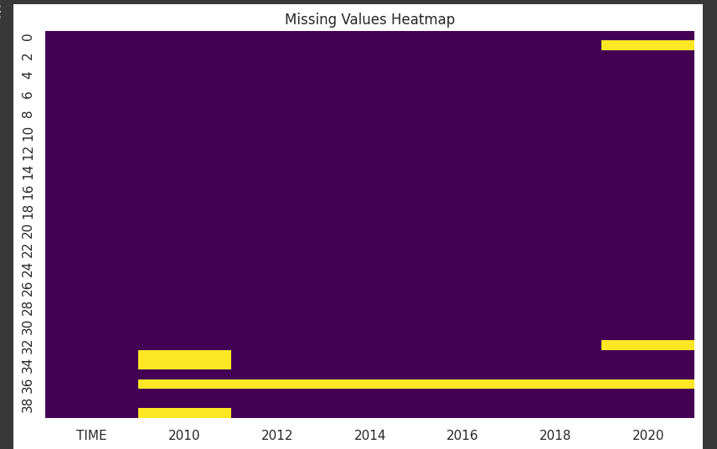

Before:

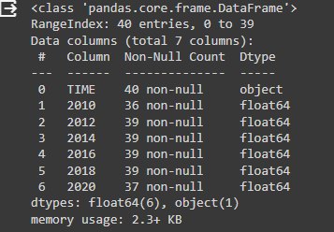

After:

